“K a b b a l i s t i c A s t r o l o g y ” – P a r t 2
By Derek R. Seagrief – Leader of School for Living Kabbalah
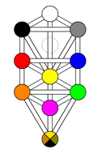
Saturn is the principle of Understanding in Kabbalah. By the time of the first Saturn Return at around 29 years, many people have established the basis of their life. Youthful illusions have usually been tempered by the reality check offered by Saturn, as we experience success, failure and various responsibilities. Also by this time parents have begun to age and the grandparent generation has started to die off. This stimulates reflection about life, death and what understanding there is of them, according to one’s level of development. This is the hallmark of the Saturn cycle.
The Uranus cycle is about 84 years or a full lifetime. This planetary principle is concerned with Wisdom in Kabbalah, or flashes of revelation about the significance of life. About midway through the Uranus cycle, the “mid-life crises”, transit Uranus forming the opposition to its natal placement occurs - a period of disruption and confusion, out of which can come a new direction or a correction of a negative or unauthentic lifestyle. If the opportunity of a Uranian reorientation is not taken up, individuals often begin to slow down as crystallisation sets in that can lead to psychological death long before the body ceases to function. For those who open up to a wider field during their Uranus opposition, the perception of life greatly alters & they begin to see how their years of experience indicate the direction of their destiny.
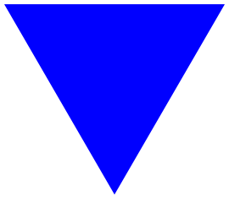
- TRIANGLES OF INTEGRATION
- 0-28 years: centred upon Sphere 9: The Moon – EGO PERSONALITY
- 28-56 years: centred upon Sphere 6: The Sun - SOUL
- 56-84 years: centred upon the invisible Sphere 11: Pluto – SPIRIT

The significance of the 3 cycles of 28 years
Shakespeare wrote about the 7 Ages of Man, starting from the Moon during infancy and ending with Saturn at old age. From Dane Rudhyar’s work, the number 28 represents a major stage in the integration of the individual (4 x7) – and that the fully worked out process of Individuation requires a symbolic duration of 84 years - three cycles of 28 years. To the Kabbalist, these numbers are related to the spheres that govern the origin of the source of the Masculine & Feminine Pillars on the Tree. Sphere 2 is governed by the first transpersonal planet, Uranus, planet of Eternity, with its cycle of 84 years, and its opposite Sphere 3, governed by Saturn, Lord of Time, Head of the Female Pillar of Form or structure, and symbolically representing every 7 years and 28-year cycle.
The story of Life begins in Space (Sphere 2). Space is also represented by the Zodiac, the traditional correspondence to Chokmah. Space needs Time to manifest, and time (the planets) needs space to act. As the planets travel through the 12 arcs of space they reveal themselves in our consciousness. In the classic Kabbalistic astrological text, The Zohar, it is said that Saturn is responsible for the timing and release of various planetary karma.
Ages 0-28: Moon as coordinating center
When we apply this to the Tree of Life, we can clearly recognize that the first 28-year cycle is the youth becoming a real individual, fulfilling the past (personal, family & racial karma), finding his or her own ideals and coming of age. On the Tree we see the triangle joining Spheres 10-8-7 (Earth-Mercury-Venus) with Sphere 9: Yesod (Foundation), governed by the MOON, as the major integrating center for this triangle of the Ego-Personality. The Moon and its eternally repetitive cycle of New Moon & Full Moon, is our link between the inner and outer realms of the solar system, the link between our conscious ego and the God within.
The 4 Spheres, Malkuth (10), Hod (8), Netzach (7) & Yesod (9), located at the bottom of the Tree, represent our Personality. All of our thinking (8) feeling (7) and sensing (10) is affected by what has happened to us in the past (9), whether we are conscious of them or not. Part of our work in using the Tree of Life is to delve into our past and start releasing the energies that have been blocked here. The main task here is to create a dynamic & living balance between our thinking, feeling & sensing functions. We relate to the world through these functions, so the clearer we are in understanding and using them, the more effective we become. Also, the more work we do to balance these spheres, the more able we are to receive energies coming from higher up the Tree, or deeper inside ourselves.
“Life begins at 40” is a well known saying and in the Jewish tradition you needed to be married, with family & 40 years of age before embarking upon a study of Kabbalah. This can be better understood when you apply the astrological Key. The spheres of Venus-Mercury-Sun, form the upward pointing Awakening Triad on the Tree, as the Ego-Personality aspires towards the higher frequencies of the Soul. To be awake is to be aware all the time i.e. not operating from the ordinary consciousness of the Yesod Ego but from the Self of Tiphareth. Their astronomical cycle repeats a precise correspondence to the 40 year cycle of conjunctions, suggesting that at this point in time, the human being is consciously moving from the Personality realms of the Tree into the Soul dimensions.
The root meaning of Spheres 7 (Venus) and 8 (Mercury) are very revealing in this context. Their Hebrew titles are translated as Eternity & Reverberation, which in the physical body means the principles behind our voluntary & autonomic body systems, while in our psychological life, they represent the constant repetition of our same thoughts or mind-sets & emotional patterns. In fact, our identity is more or less synonymous with attachment, as we get attached to ideas, opinions & things. Our first psychological death is the transition from the Moon to the Sun, from existing as part of the family, group & society, to existing as an individual. In the Moon lies the fear of separation and loneliness, fear of being outside & not belonging. There is normally much fear, pain and loss associated with the development of individuality.
Kabbalistically, it is only through contact with the energies of the Sun, representing the 6th. Sphere of Tiphareth, meaning Beauty, that we can break these endless patterns, and experience how we are interconnected with the Whole. This evokes within us our increased contact to the faculty of intuition or whole-seeing. Visually you can this concept illustrated by the fact that Sphere 6 has more pathways emanating from it to all levels of the Tree than any other sefirot.
4 Ego Types
The ego wears a face called a persona which is a functional device to meet the world. (See Diagram) The 4 Ego Types
- Hod-Yesod-Malkuth – Thinking type – Element of Air
- Netzach-Yesod-Malkuth – Sensual/Sensation type – Element of Earth
- Hod-Tiphareth-Yesod – Intuition type – Element of Fire
- Netzach-Tiphaeth-Yesod – Responsive type – Element of Water
The Tree of Life shows us 4 Ego types, which parallels the modern Jungian School of Psychology and probably the original meaning of the 4 Humours in ancient medicine, which considered the balancing of the Phlegmatic, Melancholic, Sanguine & Choleric elements in a man as crucial to his health & well-being. These 4 Ego types all pivot on the Moon sphere of Yesod.

You will immediately recognize that each of the three integrating centers of Moon, Sun & Pluto, are positioned upon the Middle Pillar of Consciousness, for it is here that a successful integration of opposites is achieved. The Moon promotes the integration of our Ego Personality, leading to the Sun as the integrating center for the Soul, and finally dark Pluto, the outpost of our Solar System, responsible for collective Karma and our integration into the mysteries of Spirit.
Back to our basic schema. From 0-7 years sees the development of the power of self-awareness as the child learns to differentiate between objective & subjective perceptions, and explore the body with its physical senses (Sphere 10: Malkuth: Earth). From the ages 7-14 the feelings and astral nature matures (Sphere 7: Netzach-Venus) and at around 14-21 the focus is upon our mental body & powers of communication (Sphere 8: Hod-Mercury). At 21-28 years we truly begin to coordinate the 3 worlds of the ego-personality, our body or physical senses, with our mind & feeling nature, as we relate our inner world with meeting the conditions of the outer reality. This is the stage known as “the Second Birth” and what this is to be depends on the results of the entire first 28 years. This doesn’t mean that a youth of 28 will become a truly realized individual, but that he/she begins the stage of truly individual development. The Sphere of the Moon is related to our past, both early childhood in this incarnation and the inheritance from past lives - and it is upon this foundation that the rest of our journey evolves. Many of our past life interests and relationship themes are repeated during the first 28 year cycle.
Ages 28-56 – Sun as coordinating center
From the ages 28-56, we have entered into the “Second Birth”, as we are now focussed upon building the Present, in contrast to the 0-28 cycle where the Past was the dominant characteristic. In the third and last 28-year cycle, from 56-84, we place the focus upon building consciousness for the Future.
During this second 28-year cycle new ideas are born, new departures initiated, and the truly individual work of one’s destiny becomes clearer. The ages 35-42 see the transits of Saturn & Uranus prominent in the life, bringing the overshadowing presence of Spheres 2 & 3 into our personal alchemy and promoting major life changes. Then at age 49 (7 x 7) can often represent a time of great social activity and influence.
On the Tree we see the triangle joining the Spheres 9-5-4 (Moon-Mars-Jupiter) with Sphere 6: Tiphareth (Beauty), governed by the Sun, as the major integrating center for this triangle of the Soul-infused Personality. Kabbalah shows us that the Soul can be defined by the triangle of Mars (Will), Jupiter (Love) & the Sun (Self-Realization). In the physical body these three planets are responsible for the overall immunity, our health & well-being. The primary colours of Red, Blue & Yellow identified with these three spheres, forms the “S” insignia of the comic book hero, Superman. Within these realms we experience the giant within us.
When we leave the realms of the Ego personality, (Spheres 10-9-8-7) we enter the dimensions of the Soul (6-5-4), although it should be understood that we don’t leave any part of the Tree in our evolutionary journey of remembering - we embrace that dimension of life represented by each of the ten Sephiroth in one great process of inclusion. Unfortunately in man, Malkuth, the 10th. Sephirah, has broken its links with Heaven. This is our ultimate Destiny, to restore communication between As Above, So Below, and become truely multi-dimensional. To know “God” is to know the numerous qualities of God – and the more we learn of these qualities, the closer we are getting to our divine origin.
When our center of gravity is positioned in Tiphareth, the goal of human evolution, we experience how all things are truly interrelated, that there is no longer the artificial division between the Lower & Upper worlds because nothing is now separate. We have entered into the spiral of loving consciousness.

Ages 56-84 – Pluto as coordinating center
At 56 the third 28-year cycle begins, coming to close at the age of 84, which marks the theoretical and symbolical completion of man’s Inner Temple. During the period 56-84, it is time for man to face the Spirit and perhaps to become transfigured by Spirit – or by one’s own work. Man become orientated towards death or immortality. At 63 years we see the combined culmination of the cycles of 7 and 9, spirit & matter, the individual & the collective, with all the archetypal potential for fusing together upon a new level of harmony. Then at 70 sees the prospect of the “Third Spiritual Birth”, with entrance into our new relationship with Spirit – if the organism can repolarize itself according to this new rhythm.
On the Tree we see this Triangle of Destiny, linking the Spheres 6-3-2 (Sun-Saturn-Uranus) with the invisible Sphere 11: Daath, the Hebrew word for Knowledge. This Sefirot only comes into manifestation at a certain stage of our evolution, connecting us with other universes & other life forms. Modern Kabbalah ascribes the planet Pluto to this mysterious realm, and responsible as the major integrating center for this Cosmic Triangle. This Triad contains the consciousness of the Universe. There is nothing personal about it – it is Cosmic.
In the natural zodiac, the polarity Leo-Aquarius, represents the Power Axis of the entire physical body, symbolized by the Heart and Blood circulation. Aquarius has two planetary rulers, traditionally Saturn, governing Capricorn by Day and Aquarius by Night – and then the modern ruler Uranus. Leo is governed by the Sun, the Heart of our Solar system. On the Tree this becomes Spheres 2 & 3 and 6. It is these two in conjunction with Tiphareth that generate the bio-electric organism.
One of the physicist’s problems of the sub-atomic world is easily resolved through Kabbalah. On the Column of Form we have Particle Theory and on the Column of Force, the Wave Conception. Between them is the Axis of Equilibrium, which makes them both equally true, depending on which theory you apply. At the center of this great Triad of Spirit is the invisible center of Daath. Now from a strictly body view it is the Knowledge of the DNA Code Chains – the body’s knowledge of itself. It is also a direct knowledge of the Absolute.
Pluto, the non-sefirah, relates to any age in which a knowledge of other realities comes to the person. This Pluto principle is also associated with recalling life before birth & knowing something about the future. According to kabbalistic tradition, the state of higher consciousness experienced in the earliest years of life is often forgotten until the prophetic faculty is reawakened, sometimes as a result of a Pluto transit.
Daath is said to be the Tiphareth of a Tree in another dimension – our link with the Spiritual Sun behind our physical Sun.
Daath will concentrate on the perfect union of the male-female polarities. Daath’s great mystery is identified with the expulsion from Paradise, sexuality & taboos, representing the “fallen Earth” sphere of Malkuth, which ultimately becomes rejuvenated to become the New Jerusalem or “perfected Earth”.

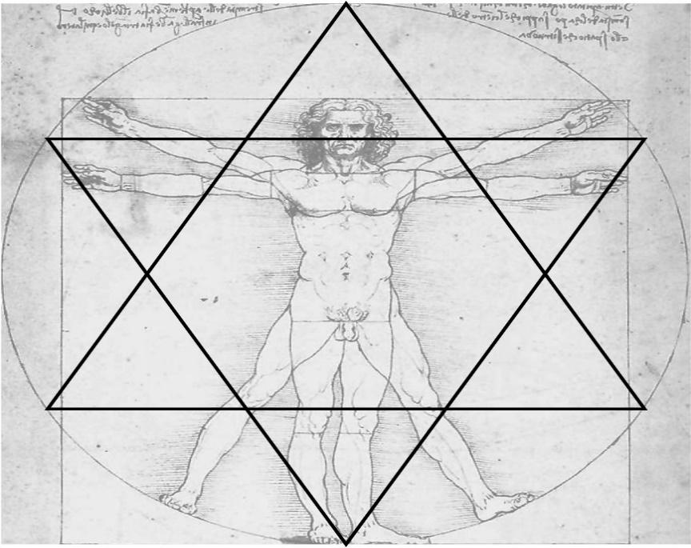

© Derek R. Seagrief
Email: derek@seagrief.com
Mobile: +45-23 81 76 18
Derek’s new Online Training & Education:
- Kabbalistic Astrology - 33 Lessons
- Become a Kabbalah Coach – 33 Lessons

