“K a b b a l i s t i c A s t r o l o g y ” – P a r t 1
By Derek R. Seagrief – Leader of School for Living Kabbalah
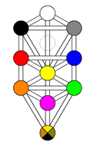
“Siman Tov U’Mazzal Tov!” These are the words from the Jewish wedding song. Translated it says: “May we, and all Thy people Israel, have good luck!” It is a joyous song, and it is sung over & over by the happy participants who never realize its true meaning. The words Siman Tov u’Mazzal Tov mean very simply, “Good aspects and good constellations!” So the song really means: “May we, and all Thy people Israel, enjoy good planetary aspects in fortunate constellations”.
When Jews greet each other with the words Mazzal Tov, by which they mean “good luck & congratulations”, they rarely realize that what they are really saying is, “May you have fortunate constellations.”
A trine aspect of 120-degrees is considered “fortunate” due to the flowing nature of the energies involved. A Grand Trine is three trine aspects that joins 3 signs of the same element together. The symbol which has become the archetype for the Jewish peoples, the so-called Star of David, is two Grand Trines, one pointing to Heaven, the Fire triangle, and the other to Earth, the Water triangle. It is a wonderful symbol for the perfect balance between the worlds.
Kabbalah and Kabbalistic Astrology is almost totally unknown in our part of the world. This new series of articles will explore what it is in Part 1 and how we can apply the principles in Part 2. The main focus for Kabbalistic Astrology is the diagram known as The Tree of Life. We don’t know the remote origins or architect of this symbol, yet accumulated experience during the past 2000 years makes it convincingly evident that its geometric design & story are in the purest mystic tradition, genuinely inspired, not invented. The diagram itself is simple and clear. Its interpretation is rather complex, for it pictures a vast network of cosmic relationships, showing us the Laws of Life in motion. Those who work with Kabbalah & Kabalistic Astrology quickly find new meaning in the expression that we are made in the image of God, created in the image of the Tree of Life. Essentially the word Kabbalah means “to receive”. Working with Kabbalah is a process of meeting our full life, preparing ourself to receive these energies, teachings and mysteries.
The Laws of Existence work at many levels. In the body there are various rhythms & these are carefully coordinated by an overall plan which adjusts to different circumstances such as the time of day, season and physical age. Then there are the Laws which govern the psychological unfoldment of the human psyche, working together with our biological clock. Psychologically orientated astrologers will recognize that this clearly includes the timing of planetary movements throughout our life. And behind all of this are Spiritual Laws that challenge us to evolve and bring the Light of Spirit down into our everyday world. Now imagine a working road-map that enabled you to successfully navigate your journey through life, experiencing the physical, psychological and spiritual dimensions of who you are – You are now approaching the blueprint of reality that Kabbalists call the Tree of Life diagram. Kabbalah is normally associated with the mystical Jewish tradition and the esoteric, a word meaning to be “hidden”. The implication is not of “secret” but unnoticed, because the more subtle laws & processes of Existence cannot be recognised by those who only perceive the universe through the senses.
Kabbalists accomplished an amazing feat. They devised a way of understanding the vast personality of God, of which you & I are a part, by breaking it down into ten aspects, called the sefirot. As the Light of the Divine moved towards our physical plane, it went through a series of transformations, much like the metaphor of a cup overflowing and filling the next cup, in an unbroken series of 10 cups.
Modern Kabbalists assign planets to each of the 10 Sefirot. Planets as representatives of the Sephiroth are actually the physical homes of an indwelling spiritual Intelligence. Then there are Twenty-Two Pathways connecting the different branches and this produces the completed Tree of Life. Each of these pathways is identified with one of the 22 Letters in the Hebrew Alphabet - with each letter representing an esoteric tool used by God in the Creation of the Universe. God divided the 22 Letters into three divisions: Three Mother Letters, represented by the transpersonal planets Neptune, Uranus & Pluto; Seven Double Letters, representing the 7 classical planets of the ancient world and Twelve Single Letters, symbolizing the 12 signs of the Zodiac. The Yod aspect or Hand of God that we use in astrology is the 10th. Letter of the Hebrew Alphabet. The 4 Elements were illustrated by the division of the 10th. Sphere, the Kingdom, into four divisions, as well as the division of the entire Tree into 4 Worlds.
Kabbalists grouped these aspects together in different combinations and assigned qualities to those groupings. The Signs of the Zodiac in the Tree of Life define the functions of the triads formed by the planets. The ten planetary-ruled signs fill all the side or functional triads, while Sun-ruled Leo and Moon-ruled Cancer known as the Gates of the Zodiac, form what are known as the Great & Lesser Faces on the Tree. (See diagram)
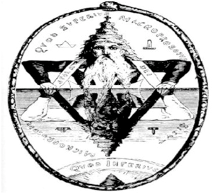
The Upper or Great Face is described by the configuration created by Neptune, Uranus, Saturn & the Sun. This one might also call the Supernatural Man. Destiny, or the fulfilment of a cosmic task, is the hallmark of this level. Below this lies the natural man formed by the Sun, Venus, Mercury and Earth complex, with the Moon at its center. The Sun, it will be noted, is at the mid-position between Heaven and Earth, that unique position held by man. We, the 4th. Kingdom in Nature, can operate in the three kingdoms below us (mineral, plant & animal), earthbound and imprisoned in the Lower Face, and yet still have access to the three kingdoms above us, symbolized by the Greater Face. As we shall explore in this series of articles, Kabbalah shows a precise correspondence between the Sun and the essential Self and the Moon and the Ego, plus all the planets and the various psychological functions. In Part 2 we shall be exploring the meaning of placing the individual horoscope upon the Tree of Life – this is called a Tree chart.
The task for the Kabbalist is to push the threshold of consciousness up the Tree, to become self-conscious by placing the focus of awareness into the Soul region, the heart of the Tree. This means that one becomes directly involved with the great struggle between order & chaos that has gone on since Creation begun. To tread the path to the heights, one goes to work on changing the personality to be more in line and fit the needs of the true individualizing Spirit.
The solar system studied by astronomers is a group of physical bodies – but the Spheres of the Tree of Life is a series of spiritual regions & together they create a magnificent Celestial Being. There is cosmic order in the descent of divinity through the 10 Sefirot, as vibrations become denser until we reach the final 10th. sphere of Malkuth, Hebrew for Kingdom, which represents our physical world. All the other worlds before this are non-physical dimensions. The world created immediately before our own Earth was that of the Moon. This 9th. Sephiroth is the sphere of the Astral Light – the etheric blueprint upon which the physical universe is built. Yesod-Moon receives the energies from all of the Sephiroth above it which are then combined into a type of pattern for the physical world to follow. It is for this reason that the Hebrew word Yesod means Foundation.
“Those who have made themselves worthy to know the Christ at His Second Coming, are those who have the Ten-fold power written upon their foreheads” – Revelations Chapter 1:17 & 22: 4.

Tree of Life in Christian Bible
In Genesis, the first book of the Bible, Moses wrote the story of Creation that can only truly be appreciated with Kabbalistic Keys. In the first pages of the Old Testament we find the Tree of Life in the Paradise of the Unawakened man. Again, on the last page of the New Testament, the Book of Revelations, in the New Jerusalem, it is the home of the Enlightened one. The Tree of Life therefore becomes the Key to the Mystery of Creation. The Tree in Paradise presents its sustaining quality and promises the continuity of life. In the New Jerusalem the Tree tells of 12 manner of Fruit – symbolic of the 12 zodiacal signs – and reveals its leaves to be the healing life force of humankind.
In the Garden of Eden we read that there was the Tree of Life & the Tree of Knowledge of Good & Evil. Both were forbidden to man’s use, yet Eve ate of the Tree of Knowledge and fed Adam from it, and thus came about the forced exodus from Paradise. For the student of Kabbalah & Kabbalistic Astrology, the essential point here is that we ate, or rather took-in & digested the energies of the Middle Pillar of Consciousness, self-awareness.

“And the Lord God said, Behold, the man has become as one of us, to know good & evil; and now, lest he put forth his hand and take also of the Tree of Life, and eat, and live forever.” – Genesis 3: 22

By exchanging the Paradise metaphor of Good & Evil with the symbolic Pillars of Mercy & Severity, with the middle synthesizing Pillar of Mildness, on the Tree of Life, a practical dimension was then added to our understanding of ourselves and the universe. Kabbalah calls this the Right hand Pillar of FORCE & the Left hand Pillar of FORM, which often gets translated as the Masculine & Feminine Pillars of Existence, with the balancing Middle Pillar of Consciousness. Together they are the Trinity of Freedom, formed by our Free Will, the duality of manifest existence and the harmony achieved through the integration by making opposites complements. In China this trinity was known as the Tao, Yang & Yin, and in India they were called Sattva, Rajas & Tamas. This triangle of primordial principles is to be found in many other cultures. All agreed that these were the three basic pillars of Existence. This phenomenon is set out in the Kabbalistic Tree of Life diagram.

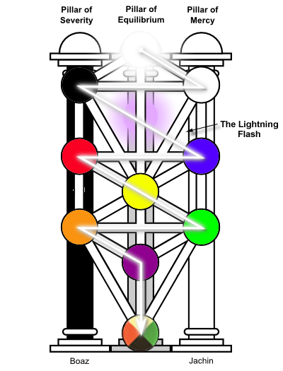
At the very top of the Tree is the first emanation of God, corresponding with the planet NEPTUNE, our Divine Self. This planet defines what each generation holds as its spiritual ideal. In this first Tree branch, the Supreme One is an undivided entity – all differences are excluded. The separation in the second Tree branch shows us that duality marks the beginning of Creation. Polarity comes into being because differences must and therefore do exist.
The second sphere is called Chokmah in Hebrew, which means Wisdom, Traditionally it was called the Second Splendour or Halo, a mirror image to the Crown. The undivided space of Number One, containing All-Things & yet No-One thing, symbolized by a circle, divides into twelve uniform spokes to form the infinite wheel of the celestial Zodiac. This was not only a reference to the zodiac circle & starry constellations, but that our Spiritual Destiny is connected with the stellar regions – Every Man & Woman is a Star. Interesting don’t you think, that the English words Destiny & Destination have obvious links. Naturally this teaching offers much fruitful discovery for the intuitive astrologer. Modern rulership places the planet Uranus at Sphere 2, Chokmah-Wisdom, for this is the Big Bang of Creation.
In Part 2 of this series, we shall be exploring how Spheres 2 & 3, Chokmah-Uranus ruled and Binah-Saturn ruled, Wisdom & Understanding, which at positioned at the head of the Pillars of Force & Form, play their vital role in our existence and evolution.

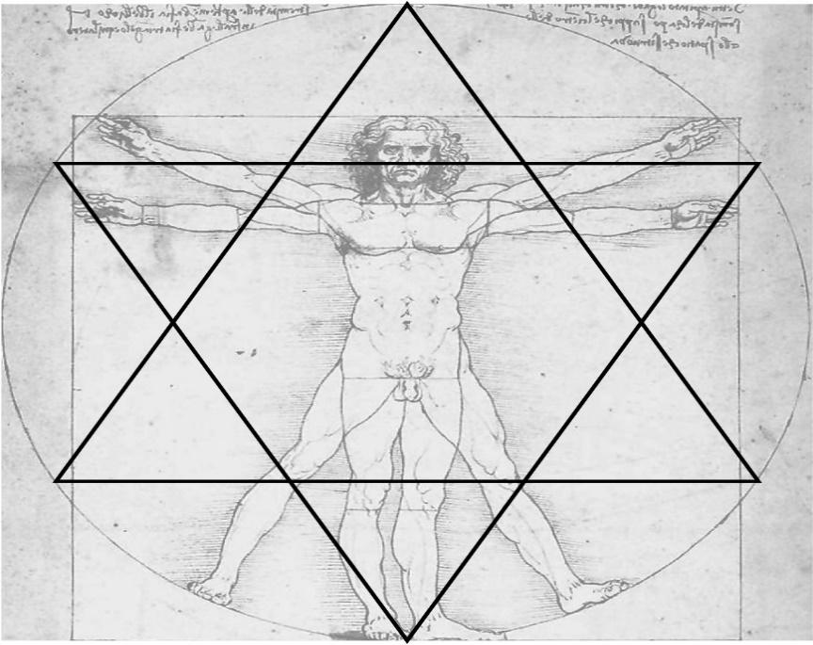

© Derek R. Seagrief – Copenhagen, November 2014
Email: derek@seagrief.com Mobile: +45-23 81 76 18
Derek’s new Online Training & Education:
- Kabbalistic Astrology - 33 Lessons
- Become a Kabbalah Coach – 33 Lessons

